3. Pasteur/Crabtree Effect

a. CO effect:

i. Co competitively inhibits cytochrome C oxidase from normal functioning. This causes chemical asphyxiation of cells to occur because Oxygen is not reduced which stops NADH oxidation to NAD+, ATP generation, and the electron transport chain from working properly. Yeast produces ethanol to continue ATP synthesis instead of taking in carbon from glucose.

b. Ethanol Intoxication:

i. This happens because the conversion of ethanol to acetalaldehyde produces NADH. Lactate dehydrogenase reduces pyruvate to lactate and this reduction is coupled with the re-oxidation of NADH to NAD+

c. Alternative Route

i. An alternative route to get from ethanol to acetyl-CoA that would be energetically more favorable would be going from ethanol🡪 acetaldehyde🡪 pyruvate. But this pathway is not used probably because the original reaction: pyruvate 🡪 acetaldehyde has a large negative delta G which means it would be irreversible, so the new preferred pathway probably wouldn’t be used.

d. Acetate formation by *Acetobacter* and ATP production:

i. The organism makes ATP through aerobic respiration so the re- oxidation of NADH to NAD+ uses oxygen as the electron acceptor as opposed to pyruvate.

e. Why some yeasts make ethanol under aerobic conditions:

i. Ethanol can kill off competitors (it can kill bacteria by making lipids more soluble in water and then denature proteins in the bacteria)

ii. Ethanol can balance of redox reaction with too much glucose. Energy is produced much faster this way.

4. Entner-Doudoroff Pathway

a. Yields

i. ATP per glucose is: 1. Glycolysis produces 2 ATP per glucose molecule. Enter-Doudoroff and glycolysis both produce 2 NADH molecules per glucose.

b. *Z. Mobilis* vs. yeast

i. *Z. Mobilis* consumes more glucose and produces less ethanol than yeast because it produces less ATP. In anaerobic conditions, 2 times as many glucose is needed by *Z. Mobilis*. The Entner-Doudoroff pathway does not produce as much ATP so it has to work twice as hard.

c. Development of anti-cancer compounds

i. Cancer cells prefer using glycolysis so if you could inhibit glycolysis, you would kill cancer cells, but the drawback of this method is that glycolysis inhibition is not specific to cancer cells (yet ☺) so you would also kill healthy cells.

d. Heterolactic Pathway: 2 reactions that distinguish

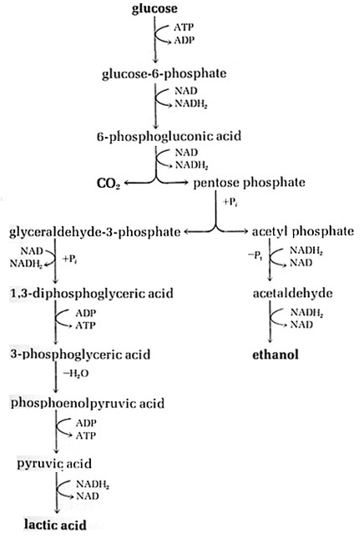

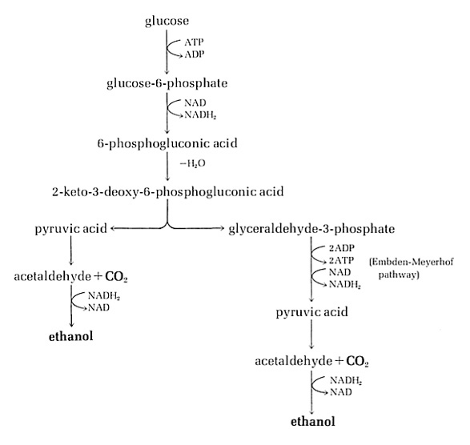

i. Differences are in the 2 branches after the reaction from 6- phosphogluconic acid 🡪 G3P & acetyl phosphate. Entner-Doudoroff (left) goes from 6-phosphogluconic acid🡪 pyruvic acid & G3P and each of those goes on with their own reactions and intermediates and differ.

ii. In the heterolytic pathway, 3 NADH are produced. In Entner- Doudoroff pathway, 2 NADH are produced. These numbers signify. The heterolytic pathway produces 1 ATP.

e. Mutation

i. A mutation on a heterolytic acid bacterium that eliminates activity of the enzyme that converts acetyl phosphate to acetaldehyde would not be able to grow on glucose because the redox balancing part is gone so it is no longer self sustaining, but limited.